Power Point Tutorials


Items highlighted in yellow are tasks for you to complete
Items in Blue italics are help tips

These pages are designed to show you how to use software packages; various software updates may have taken place so some pages will not apply to versions other than those listed here. In some cases data files may be required.

MP116 Worksheet Power Point Backgrounds

Task Brief

The steps are as follows:
- If you are already using PowerPoint, then from the File menu choose New. Otherwise open PowerPoint start and start a new presentation
Open the PORTFOLIO slide presentation.
- Click on the slide sorter
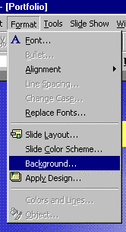

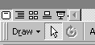

- Duplicate your slide 5 times

- Select Slide 2 and

- From the Format menu choose Backgrounds

- To insert a different background to each slide you will need to click on the select button
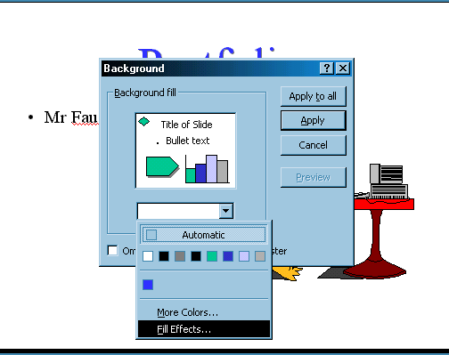

and on Fill effects, change each slide as follows
- Plain Colour
- Pattern
- Gradient (Two Colours)
- Gradient Preset (Choose one)
- Texture
- Picture

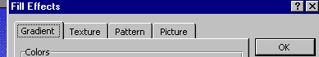

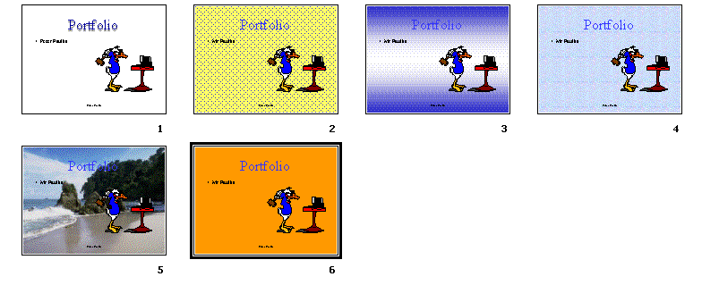

HEADERS & FOOTERS (Slide Master)
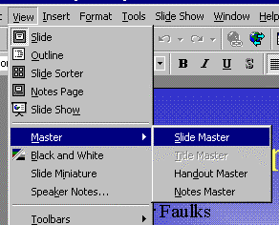

- Open the slide master View • Master • Slide Master and type your name into the footer area

- Change the footer to include your name then click Close or view slide
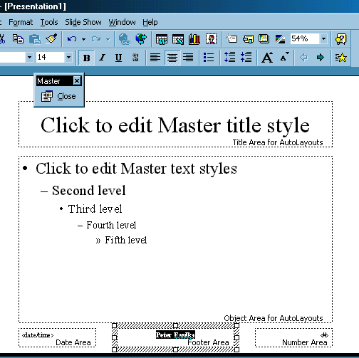
Name here

- Select slide 2 and title this Slide 2

- Select slide 3 and title this Slide 3

- Number all remaining slides so that they have Slide No, and also they should have Portfolio and your name.

- Select Slide Show menu and create a different slide transition for each slide

- Select Slide Show and make the transitions change automatically through a range of seconds

- Select the word “Portfolio” and from Slide Show Menu select Custom Animation – create a different animation to your word on each slide.
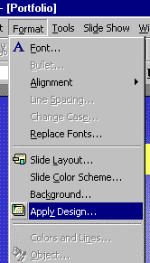
- Save this file to your folder as Porfolio

- SaveAs a copy of this file to your folder as Porfolio 2

- On portfolio 2 Apply a design template

- Pick one you like and use this on your Portfolio presentation

- Select the slide transition and animation and use this on your portfolio presentation.

This Ends This Exersize


Need help just ask

